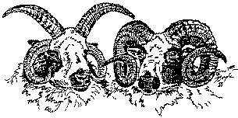

Jacob Sheep Conservancy©×
SPOTLIGHT©
Summer 2016 Volume XXVIII No. 1

Jacobs: The Original Sheep of the Biblical Jacob?

Contents

Jacobs: The Original Sheep of the Biblical Jacob? p. 1
JSC Board Votes to Accept ASJR Registrations p. 5

Report on Maryland Sheep and Wool Festival p. 5

Call for Jacob Items to Sell at the NY Festival! p. 6

Jacobs Contribute to Important Genetic Research p. 6

Your JSC Board of Directors p. 7

By Roy Deppa, President, Jacob
Sheep Conservancy

Each year at the Maryland Sheep and Wool Festival’s Parade of Breeds, the Jacob is introduced and a brief description of the breed is given by the announcer. Included in the description is always a statement that some people say the Jacobs are descended from the original flock of Jacob, as described in the Bible.

At the Festival, we are often approached by people who ask about the origin of the breed, noting that they have been told these are the original sheep from the Bible. Several years ago, I was contacted by a man in Israel who wanted me to ship a small flock of my Jacob sheep to him, as he planned to return the Jacob

The Jacob Sheep Conservancy 668 County Road 510
Belvidere, NJ 07823, 908-475-5109
www.JacobSheepConservancy.org

Sheep to the land of their origin. (Alas, it was too complicated, and I had to turn him down.)

This past spring, I was interviewed by a reporter who said that she was preparing an article on Jacob Sheep for an agricultural newspaper. When she got around to the subject of the origins of the breed, she clearly expected me to relate the breed to the biblical story of Jacob, and seemed quite disappointed when my response went in another direction.

We’re all familiar with the association of Jacobs with the Bible story; after all, they’re called Jacob, or Jacob’s sheep, aren’t they? Why else would they be called Jacob’s sheep?

This can become quite a delicate topic, and while I have my opinion on the subject, I’ve learned to be a little circumspect in responding to the question. Some people are adamant that today’s Jacobs are directly descended from the flock described in the Bible, and to question that is tantamount to questioning the Bible itself.

It’s interesting at this point to go back and read the story from Genesis chapter 30 in the Bible, to see what it actually says. The verses that follow are from The Torah, The Five Books of Moses, A New Translation of The Holy Scriptures according to the Masoretic Text, third edition, published in 1992. I used this source as it is a very clear and recent English translation of the authoritative Hebrew and Aramaic text.

Bargaining with his father-in-law, Laban, Jacob says:

Genesis 30:32 “let me pass through your whole flock today, removing from there every speckled and spotted animal--every dark-colored sheep and every spotted and speckled goat. Such shall be my wages.
- In the future when you go over my wages, let my honesty toward you testify for me; if there are among my goats any that are not speckled or spotted or any sheep that are not dark-colored, they got there by theft.”
- And Laban said, “Very well, let it be as you say.”
- But that same day he removed the streaked and spotted he-goats and all the speckled and spotted she-goats—every one that had white on it—and all the dark-colored sheep, and left them in the charge of his sons.
- And he put a distance of three days’ journey between himself and Jacob, while Jacob was pasturing the rest of Laban’s flock.
- Jacob then got fresh shoots of poplar, and of almond and plane, and peeled white stripes in them, laying bare the white of the shoots.
- The rods that he had peeled he set up in front of the goats in the troughs, the water receptacles, that the goats came to drink from. Their mating occurred when they came to drink,
- and since the goats mated by the rods, the goats brought forth streaked, speckled, and spotted young.

- But Jacob dealt separately with the sheep; he made these animals face the streaked or wholly dark-colored animals in Laban’s flock. And so he produced special flocks for himself, which he did not put with Laban’s flocks.

Of course, it depends somewhat on which version of the Bible you read, because the details differ somewhat in different translations (you can try looking at the same verses in different versions of the Bible; http://biblehub.com/concordance/ makes this easy). But what comes through in these English Language Bibles is that Laban’s flock had speckled and black sheep and goats, as well as other colors. Some versions refer to ringstraked (marked with circular strips, like a raccoon’s tail), as well as yellow and brown animals being the ones that Jacob was to keep for himself. Jacob was clever and took all the speckled, black, and diverse-colored ones, and then managed to preferentially breed the remaining sheep and goats to produce predominantly spotted and black offspring, which he kept. So obviously, spotted and black sheep didn’t originate with Jacob; he merely increased the number of them in Laban’s flock to his own advantage. (The passage contains a puzzling detail that is often overlooked: Jacob caused the breeding of the speckled goats and black sheep by placing peeled wooden stakes in front of the animals when they bred. I’ve never read a suggestion to explain how that worked, but it might make an interesting modern-day 4H project!)

That’s pretty much the total description of Jacob’s sheep. No mention of four horns, or horned females, or badger faces, or triangular faces without Roman noses. Take a look at one of the extant breed standards, and none of the features listed there existed in the biblical texts except speckling or spotted. And keep in mind that the texts are not clear that they are sheep or goats, black and white, or yellow, brown, or ringstraked. If the texts refer to what we know as Jacob Sheep, one could almost argue that they also refer to Holstein cattle or Toggenburg goats!

The authority on the history of the modern Jacob Sheep is Lady Araminta Aldington, longtime breeder and founder of the Jacob Sheep Society. She spent many years carefully researching the origins of the Jacob Sheep, and wrote the authoritative book on the subject: “A History of the Jacob Sheep” published by Geerings of Ashford Ltd in 1989 for The Jacob Sheep Society. This wonderful book cites every possible reference to spotted sheep similar to our Jacobs, from China, Mongolia, India, the Middle East, Africa, Sicily, Cyprus, Italy, Germany, and Britain. As she notes in the beginning, spotted sheep are probably the oldest breed of sheep in the world, likely because their coloring provided some camouflage protection. Thus, pied sheep (that is, sheep having two or more different colors) are to be found throughout the world and throughout history.

Our Jacob Sheep were developed in England. As Lady Aldington noted, it was common practice at many ancestral estates in England to keep flocks of sheep that were of various breeds not generally known to average farmers. Because these flocks were kept on the grounds (or “parks” of the estates), they were referred to as Park Sheep. Some of those flocks were very old, and were valued for their ornamental quality as well as for their ability to live like deer, without much attention from the landowners.

In 1911, two gentlemen circulated a letter asking if there were interest in forming a society for the preservation and improvement of Park Sheep, listing seven breeds as candidates. Number 6 on this list was “The pied sheep of Spanish or North African origin (sometimes called Syrian or Zulu sheep) and rams often with four horns”. It was apparently not until the early 1970s that the Rare Breeds Survival Trust was established to protect breeds that were at risk of extinction. In 1969, the Jacob Sheep Society was formed, with The Lady Aldington as its first Chairman. Within a month of its founding, the Society had 96 members with 2,700 sheep registered.

One of the major concerns then, and continuing into the present time, is the possible effect that establishing a breed standard and registering animals has on the “purity” of the breed. In 1974, the Rare Breeds Survival Trust noted that there were two distinct types of Jacob Sheep; the “Park”, those kept for purely ornamental purposes, and the “Improved”, that have been developed as commercial sheep by progressive breeders.

It is interesting to try to determine just when people began to refer to our sheep as Jacob Sheep. The early correspondence and literary quotes cited by Lady Aldington do not use the term Jacob; the sheep were known by a number of different names, but not Jacob.
References to Jacob become commonplace after the foundation of the Jacob Sheep Society, but even as late as the 1911 letter, the name seemed to be Pied, or Spanish Sheep. It seems likely that the name Jacob was first given to them in the mid-1800s.

So, are our sheep “the original sheep of Jacob”? It’s clear that the Jacob as we know it, a black-and-white spotted sheep, whose females are horned as well as the males, with a strong polycerate (many-horned) character, narrow triangular face, small ears, typically “badger-faced” coloring, and hardy physical characteristic, was developed over a long period as Park Sheep on large ancestral estates in England. Thus it is accurate to state that the Jacob Sheep is an old British breed. That history goes back a good 400 years, at least.

Beyond that, what were the origins of the breed? While multi-colored and/or spotted sheep are found around the world, it is likely that the ancestors of the British Jacob came from or through Spain. Spain had a long history of involvement with, and occupation by, Arabic people who came from North Africa, and some of the spotted sheep commonly found in Middle Eastern flocks very probably made their way through Spain to England. But we have no definitive chain-of-custody history that proves that narrative, so it remains speculative. There are other breeds of polycerate sheep in Britain, notably in the far north, and it is easy to imagine that the originators of the Park pied sheep used that characteristic to develop a very ornamental sheep. But, as Lady Aldington points out, there are polycerate sheep found in other parts of the world, including China and India, so we really don’t know where that trait came from.

It all makes for a remarkable, if somewhat mysterious, story. With most modern breeds of sheep, we can identify where and when they were developed. Most of those histories go back only a few decades, or maybe even a couple of centuries. Jacobs were developed in England and kept in unusual circumstances without much development for perhaps 400 years. The fact that they were kept essentially as wild animals like deer, with very

little attention from their owners, meant that they developed characteristics that assured their survival. As a result, we have a wonderful primitive and unique breed of sheep to work with.

JSC Board Votes to Accept ASJR Registrations
The Board of Directors of the Jacob Sheep Conservancy (JSC), at its annual meeting on May 8, 2016, voted to accept registrations from the American Jacob Sheep Registry (AJSR) as equivalent to JSC registrations. This was done in recognition that both the JSC and the AJSR have the same breed standards for certification and registration, including progeny testing.

Progeny testing is the process used to verify the genetic purity of breeding animals whose history is unknown. This involves examining their offspring from two breedings to different mates to ensure that the offspring display the traits and characteristics specified in the breed standard. The JSC website explains the multi-step process of progeny testing, certification, and registration beginning here: http://www.jacobsheepconservancy.com/#!certificationregistration-pr/c233r.

Once the parent sheep are registered, the process for certifying and registering their offspring is streamlined. The appropriate forms and guidance are found on the JSC website, www.jacobsheepconservancy.com under “JSC Forms.”

Breeders with ASJR-registered sheep who wish to register future sheep with the JSC need only produce documentation of ASJR registration for the parent sheep and register the new Jacob lambs using the streamlined process. For more information, contact JSC Registrar Catherine Snook at Catherine.Snook@gmail.com.

Report on the Maryland Sheep and Wool Festival
The 43rd annual Maryland Sheep and Wool Festival took place May 7-8, 2016, at the Howard County Fairgrounds in West Friendship, MD. It is the largest and longest- running showcase of domestic sheep and wool in the United States. This year, more than 40,000 attendees came over the course of the weekend to enjoy upwards of 40 sheep breeds on display and over 300 vendors, along with food, music, demonstrations, and contests.

The Jacob Sheep Conservancy once again staffed a booth in Barn 4, selling t-shirts, fleeces, yarn, roving, shawls, shawl pins and even some non-Jacob farm products. The educational Jacob Breed Display booth, which was designed and staffed by the Deppa family, won a Grand Champion ribbon this year among the displays for minor breeds.

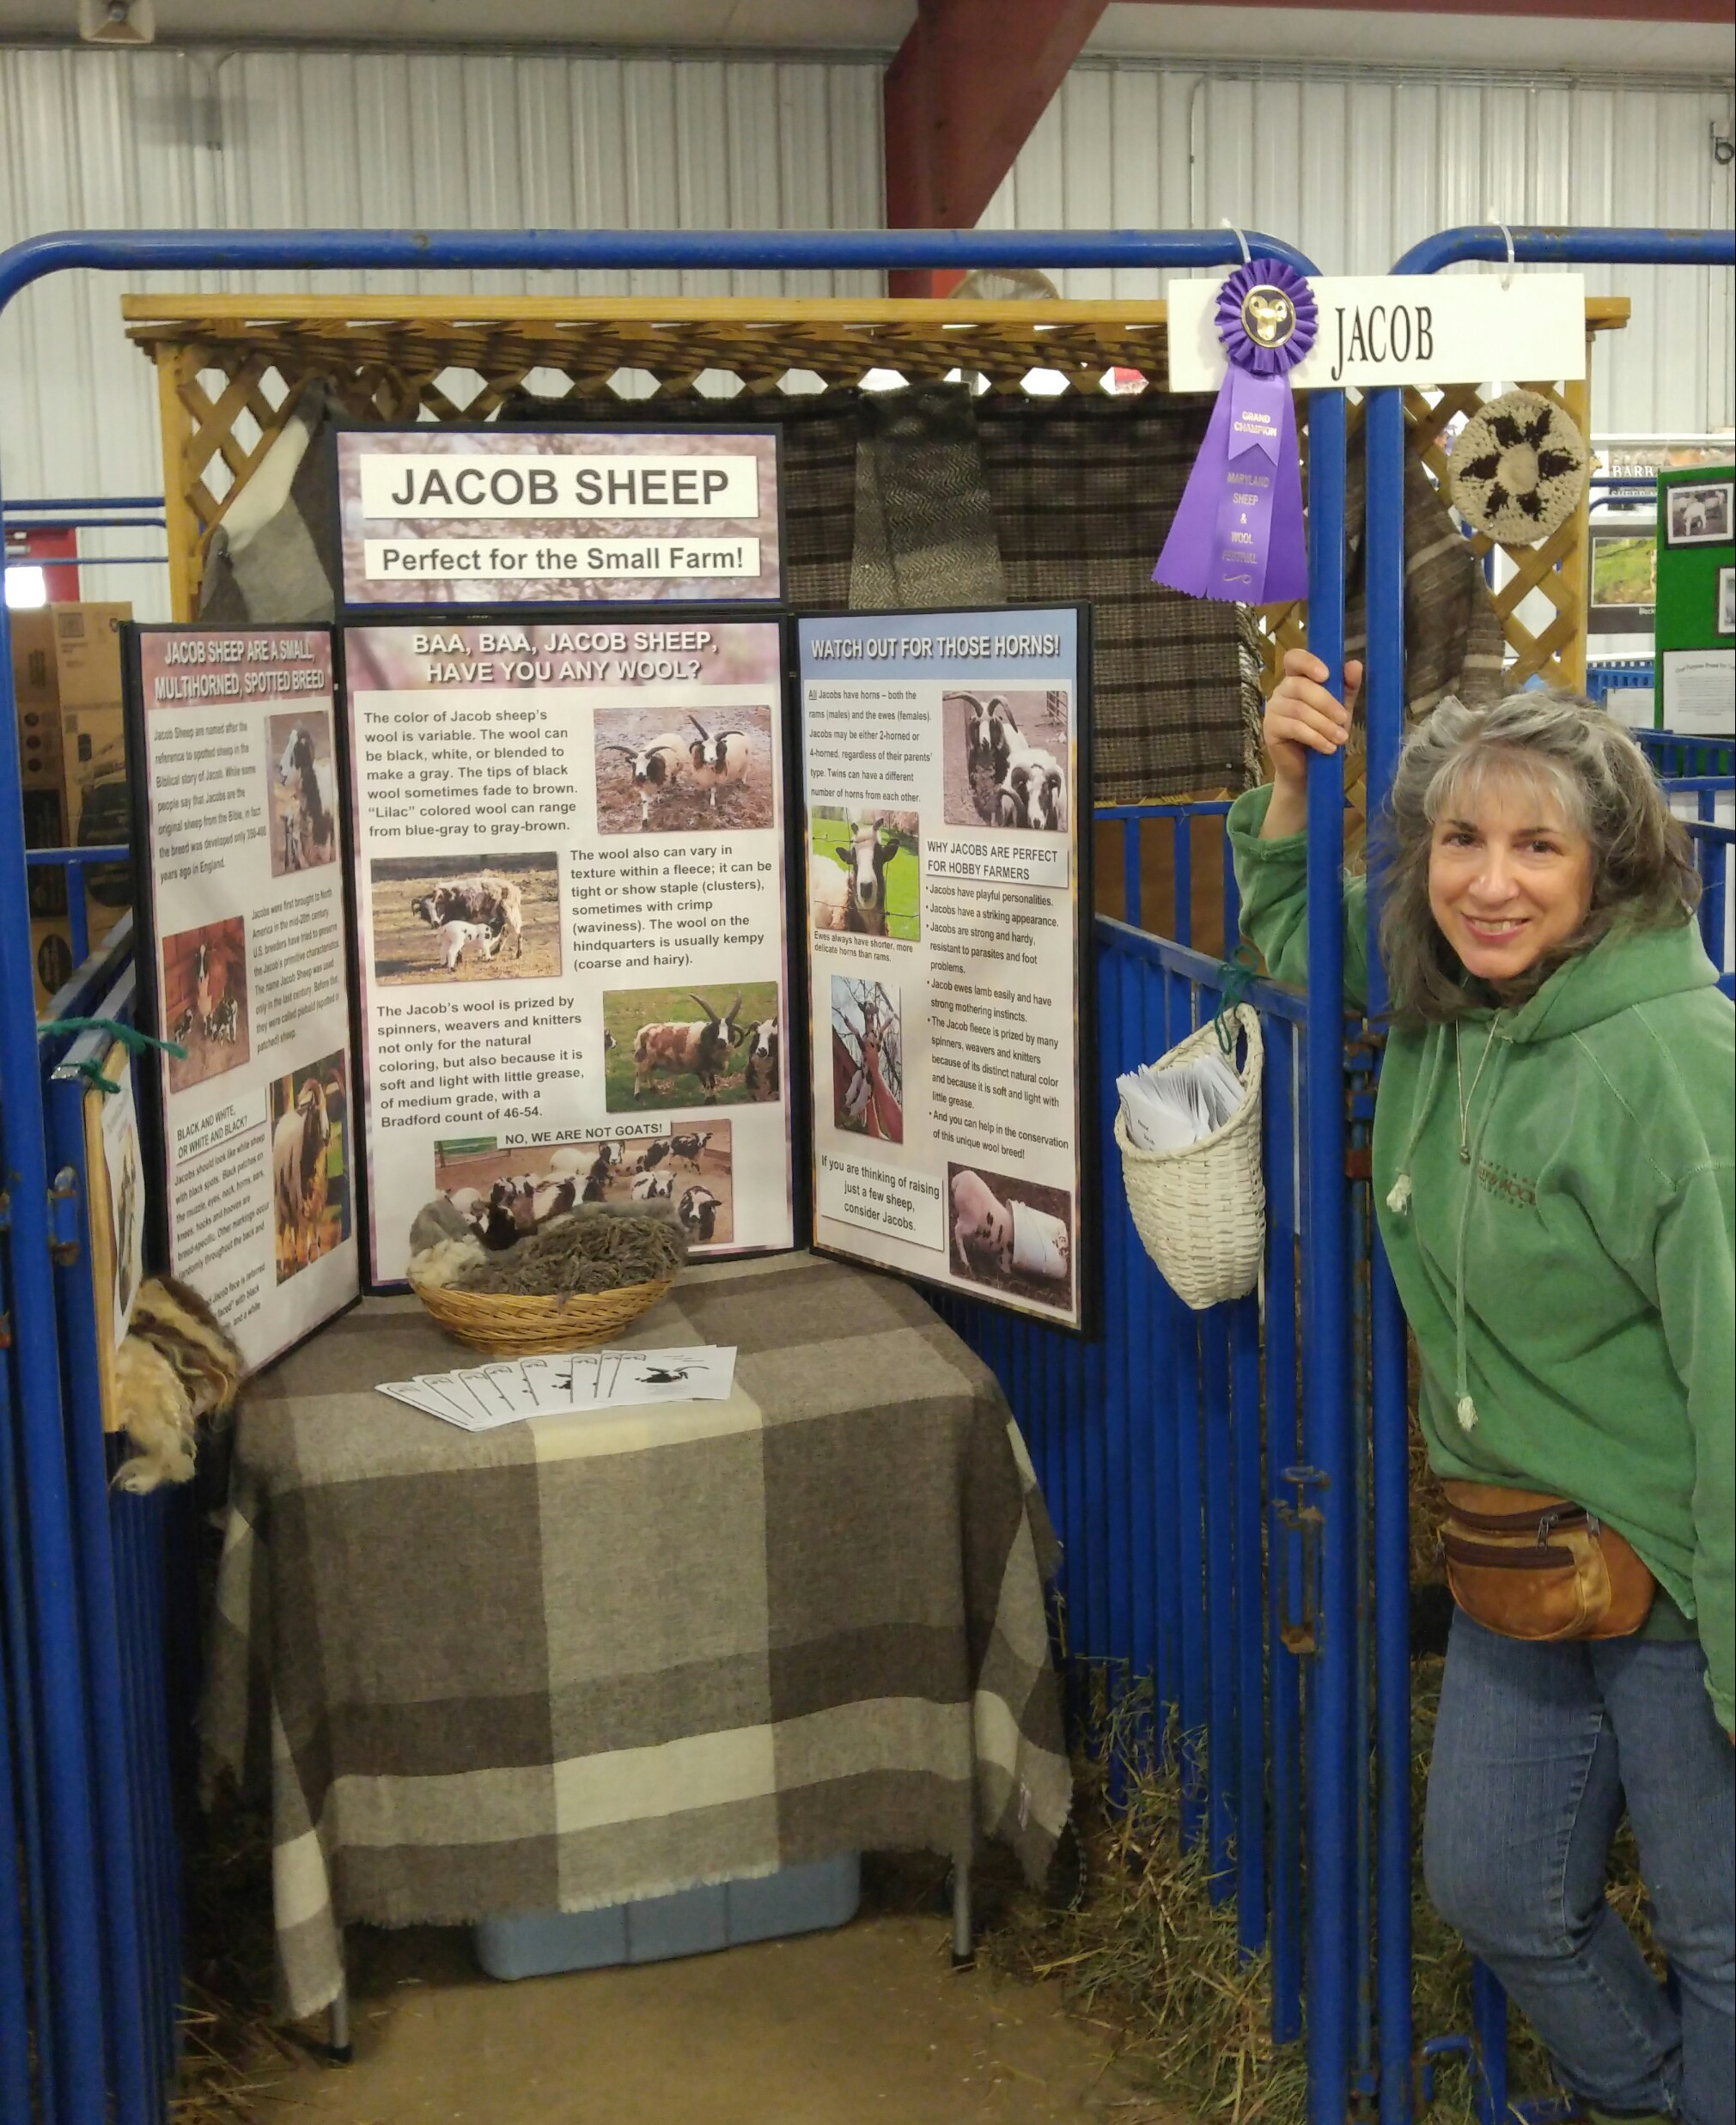
Next year’s festival will be held May 6-7, 2017. There is no charge for admission, but voluntary donations are welcome. Please consider attending and stopping by the JSC booth!
For more information about the festival, visit http://sheepandwool.org/. If you are interested in providing items to sell at the JSC booth next year (proceeds of the sale of your items goes to you, minus a 10% contribution to the JSC), contact Treasurer Joan Schnieber at jacobsheepconservancy@gmail.com.

JSC Secretary Karen Deppa at the award-winning Jacob Breed Display, Maryland Sheep and Wool Festival, May 2016

Call for Jacob Items to Sell at the NY Festival!
The Jacob Sheep Conservancy (JSC) will once again exhibit at the New York State Sheep and Wool Festival, which takes place at the Dutchess County Fairgrounds in Rhinebeck, NY, October 15-16, 2016. The JSC booth represents a great opportunity for JSC members to sell their Jacob-related products and non-Jacob farm products at one of the biggest and best-attended festivals on the East Coast.

If you have Jacob fleeces, skeins, roving, knitted or crocheted items, or other products that you would like to sell at the JSC booth in Rhinebeck, please contact JSC Treasurer Joan Schnieber at jacobsheepconservancy@gmail.com. You can either bring the items to the booth in person, or ship them to Joan to arrive no later than October 1. Income from the sale of your items goes to you, minus a 10% contribution to the JSC. Joan can provide other details and answer any questions you have.

For more information about the NY festival, visit http://sheepandwool.com/.

Jacobs Contribute to Important Genetic Research
Jacob sheep breeders, you have reason to be proud: Jacobs are central to new medical research that may lead to new treatments for Tay-Sachs disease, a rare genetic disorder that affects both animals and humans. The disease, which destroys nerve cells from a buildup of toxins in the body, has no cure and usually kills children before they are 5 years old.

As reported in the May 24, 2016, issue of The Washington Post, back in 1998, Jacob breeders Fred and Joan Horak started to seek answers for why their lambs were dying before they reached a year old. Consulting experts at Texas A&M University and elsewhere, the Horaks determined that a genetic disorder was responsible and began selectively breeding sheep to carry the problem gene to assist with further research. In

2007, it was determined that diseased Jacobs were afflicted with Tay-Sachs. Researchers then discovered that the disease in the sheep was a near-match to Tay-Sachs found in humans.

Now located in Auburn University, the diseased Jacob flock continues to be bred for research purposes. Experimental therapies with diseased Jacobs have extended their life spans from an average of 9 months to more than 14 months. The same therapies used on cats, which can also suffer from the disease, has been even more successful in extending life span. Trials with humans are still years away, but this research featuring Jacob sheep has provided hope for families where none previously existed. The full article is at https://www.washingtonpost.com/national/health-science/how-rare-sheep-from-biblical- times-may-help-kids-with-a-deadly-genetic-disease/2016/05/23/14a59c9e-d9b3-11e5- 925f-1d10062cc82d_story.html.

Your JSC Board of Directors
President: Roy Deppa, Poplar Spring Farm, Brookeville, MD, http://www.brightonflock.com/
Registrar and Webmaster: Catherine Snook, Snook Farm, Stormville, NY, http://www.snookfarm.com/
Treasurer: Joan Schnieber, Jenny Jump Farm, Belvidere, NJ, http://www.jennyjumpfarm.com/
Secretary: Karen Deppa, Poplar Spring Farm, Brookeville, MD Board member: Kelly Przylepa, Firefly Farm, Glenville, PA,
https://www.facebook.com/pages/Firefly-Farm-PA/117241838301654 Social media: Laurel Snook, https://www.facebook.com/Jacob-Sheep-Conservancy-
274422889257229/?ref=ts&fref=ts

Interested in being involved in the JSC?
Do you have an idea for an article for The Spotlight? Write to us at jacobsheepconservancy@gmail.com!

